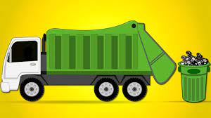
CLEAN SWEEP
Monday, May 4th 2026, will be Tuesdays route for clean sweep.
Wednesday, May 6th 2026, will be Thursdays route for clean sweep.
Tuesday and Thursday will be regular pick-up days.
NO CLEAN SWEEP WILL BE PICKED UP IF OUT.
*NOTICE ONLY PICKING UP CLEAN SWEEP ITEMS ON THE TWO DAYS LISTED ABOVE*

*CLEANSWEEP ITEMS WE CAN NOT TAKE BASED ON LANDFILL REGULATIONS:
NO LUMBER, WOOD, BRICKS OR TILES, CONCRETE, SCRAP METAL, CAR PARTS, TIRES, BATTERIES, YARD WASTE,TREES, GRASS, CHEMICALS, ACIDS, WET PAINT, MOTORS, TRANSMISSIONS, LAWNMOWERS, ANY KIND OF LARGE HOUSEHOLD APPLIANCES, GARDEN TILLERS,BURN BARRELS, ANY KIND OF CONTRUCTION OR REMODELING DEBRIS, DEAD ANIMALS, LIQUIDS OF ANY KIND, OIL, GAS, OIL FILTERS, MADICAL WASTE, OR ANY KIND OF CARPET OR PADDING*
*NO HAZARDOUS MATERIALS OF ANY KIND*
*ONLY 2 MATTRESS AND BOX SPRINGS PER HOUSEHOLD!*

